+

**DWP5431**

**Internet & Web Publishing**

*Trimester 1, Session 2021 / 2022*

ASSIGNMENT TOPIC:

**(Lecture Section: 2122 )**

BY

|  |  |  |  |  |  |
| --- | --- | --- | --- | --- | --- |
| **No** |  | | **Student ID Programme** | | **Student Name** |
|  | | 1201200637 | | DIT | Wee Chian Seong |
|  | | 1201200463 | | DIT | Lim Wee Zheng |
|  | | 1201200678 | | DIT | Law Qian Er |
|  | | 1201200449 | | DIT | Lai Jian Hong |
|  | | 1201200327 | | DIT | Ho Chun Shian |

Table of Contents

**TABLE OF CONTENTS 1**

**PROJECT EVALUATION FORM 2**

**PART 1: INTRODUCTION OF TOPIC 3**

**PART 2: SOURCE CODE FOR EACH EXAMPLE 5**

**Figure 1.1.** Example 1 **5**

**Figure 1.2.** Example 2 **13**

**Figure 1.3.** Example 3 **17**

**PART 3: SCREENSHOTS OF THE OUTPUT 21**

**Figure 2.1.1** Output 1 **21**

**Figure 2.1.2.** Output 1 Error **22**

**Figure 2.1.3.** Output 1 Result 1  **23**

**Figure 2.1.4.** Output 1 Result 2**__________________________________24**

**Figure 2.2.1.** Output 2 **25**

**Figure 2.2.2.** Output 2 Error **26**

**Figure 2.2.3.** Output 2 Result **27**

**Figure 2.3.1.** Output 3 **28**

**Figure 2.3.2.** Output 3 Error **29**

**Figure 2.3.3.** Output 3 Result **30**

**Video Link_________________________________________________________31**

**ASSIGNMENT EVALUATION FORM**

**Topic:** _________________getElementById______________________________

1. **ID:** 1201200637______________ **Name:** Wee Chian Seong________________
2. **ID:** 1201200463______________ **Name:** Lim Wee Zheng__________________
3. **ID:** 1201200678______________ **Name:** Law Qian Er____________________
4. **ID:**1201200449______________ **Name:** Lai Jian Hong____________________
5. **ID:** 1201200327_______________ **Name:**Ho Chun Shian____________________

|  |  |  |  |  |
| --- | --- | --- | --- | --- |
| **1 - Poor** | **2 - Average** | **3 - Satisfactory** | **4 - Good** | **5 – Excellent** |

|  |  |  |
| --- | --- | --- |
| **No** | **Criteria** | **Marks** |
| 1. | Following basic requirements: |  |
|  | 1. Examples given are reflecting the topic |  |
|  |  |  |
| 2. | Contents & Presentation: |  |
|  | 1. Level of understanding to the topic |  |
|  | 1. Quality of the code |  |
|  | 1. Presentation skill |  |
|  |  |  |
| 3. | Report(hardcopy) |  |
|  | Softcopy(video) |  |
|  | **Total (**30 **Marks)** |  |

**PART 1: INTRODUCTION**

The getElementById() method returns the element that has the ID attribute with the specified value. This method is one of the most common methods in the HTML DOM, and is used almost every time you want to manipulate, or get info from, an element on your document.

So, how does getElementById() work together with HTML? First, The HTML code often has an ‘*id*’ attribute, example like **<div id="root"></div>.** The ‘*id*’ is to identify a HTML element within the document. By rules, the ‘*root’* id is unique within the document, because other elements cannot have this ‘*root*’ id. Next, the ‘id’ is also a case-sensitive attribute. For example, the 'root' and 'Root' are totally different id when it is in HTML code. So, in an easy way, if you want to select the element by its id, you have to use the ‘getElementById’ method in the document.

Other than that, is **let element = document.getElementById(id); .** In this syntax, the ‘*id*’ represents the id of an element that you want to select. The ‘getElementById()’ returns to an object which describes the DOM element object with the specified id. Moreover, it will return ‘*null*’ if there are no elements with that ‘id’ exists.

As I mentioned earlier, the ‘*id*’ is unique within a document. However, HTML is a forgiving language. If a document has more than one element with the same id, the getElementById() method returns to the first one that it encounters.

So this is an example of getElementById() in HTML :

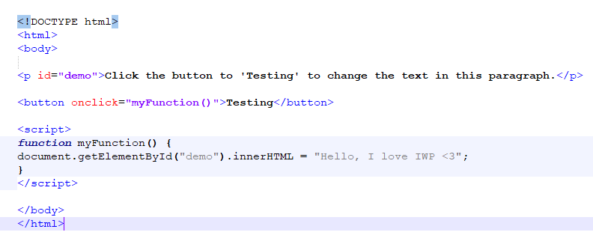

This is the example output:

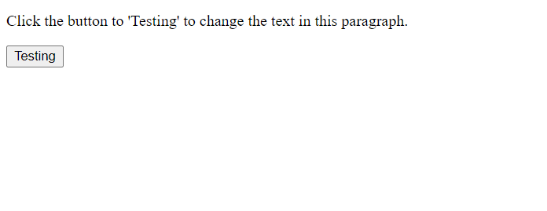

After click the button ‘Testing’ then below is the output:

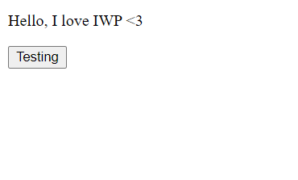

**PART 2: SOURCE CODE**

|  |
| --- |
| <!DOCTYPE HTML>  <html>  <head>  <title>MARVEL CINEMA</title>  <style>  body{background-color:#afafb6;}  .form{  max-width:650px;  max-height:1100px;  background:skyblue;  margin: 0 auto;  margin-top:30px;  padding: 20px;  box-shadow:1px 1px 16px rgba(0, 0, 0, 0.3);  border-radius:5px;    }  img{margin-left:200px;}  h1{text-align:center;}  span {color:red;  font-weight:bold;}    input[type=text],[type=number],[type=date],[type=time],select  {  border:2px ridge green;  box-sizing:border-box;  border-radius:5px;  margin-top:10px;  padding:8px;  }  input[type=button]{text-align:center;  margin-left:250px;  padding:10px;  border-radius:5px;  font-weight:bold;}    input[type=button]:hover  {    background-color:blue;  font-style:italic;  font-family:Arial;  color:white;  }  #information{color:black;  font-size:17px;}  </style>  <script>  function get_total()  {  var user_name,movie_code,a_qty,c_qty,user_date,user_time;  var name_check=0,movie_check=0,date_check=0,time_check=0;  var total=0,adult_price=0,child_price=0,m_price=0,movie_name="",movie_time="",add_on_name="";  var add_on=[];  var i=0;  var x=0;  var add_on_price=0,total_add_price=0,add_on_details="";    user_name=document.movie_form.name.value;  movie_code=document.movie_form.movie.value;  a_qty=parseInt(document.movie_form.adult_qty.value);  c_qty=parseInt(document.movie_form.child_qty.value);  user_date=document.movie_form.date.value;  user_time=parseInt(document.movie_form.time.value);    if(user_name=="")  {  document.getElementById("name-display").innerHTML="Please Enter Username";  }  else  {  document.getElementById("name-display").innerHTML="";  name_check=1;  }    switch(movie_code)  {  case '1':  m_price = 9.90;  movie_name="Avenger: The Last Game";  break;    case '2':  m_price = 14.90;  movie_name="Spider-Man: No Way Home";  break;    case '3':  m_price = 12.90;  movie_name="The Legend of the Ten Rings";  break;    case '4':  m_price = 7.90;  movie_name="Avengers:Infinity World";  break;    case '5':  m_price = 13.90;  movie_name="Doctor Strange 2: In the Multiverse";  break;    default:  document.getElementById("movie_price").innerHTML="Please Select Movie";  }    if(m_price==0)  {  document.getElementById("movie_price").innerHTML="Please Select Movie";  }  else  {  document.getElementById("movie_price").innerHTML="";  movie_check=1;  }    if(a_qty=="" || isNaN(a_qty))  {  document.getElementById("adult-qty").innerHTML="Please Enter Quantity";  }  else  {  document.getElementById("adult-qty").innerHTML="";  adult_check=1;  }    if(c_qty=="" || isNaN(c_qty))  {  c_qty=0;  }    if(user_date=="")  {  document.getElementById("date-error").innerHTML="Please Enter A Date";  }  else  {  document.getElementById("date-error").innerHTML="";  date_check=1;  }    switch(user_time)  {  case 1:movie_time="10:00 AM";  break;    case 2:movie_time="1:00 PM";  break;    case 3:movie_time="4:00 PM";  break;    case 4:movie_time="7:00 PM";  break;    }    if(movie_time=="")  {  document.getElementById("time-error").innerHTML="Please Enter A Time";  }  else  {  document.getElementById("time-error").innerHTML="";  time_check=1;  }    if(name_check==0 || movie_check==0 || date_check==0 || time_check==0 || adult_check==0)  {  alert("Please Fill Up The From Correctly..");  }    for(i=0;i<document.movie_form.add.length;i++)  {  if(document.movie_form.add[i].checked)  {  add_on[x]=document.movie_form.add[i].value;  x++;  }    }    for(i=0;i<add_on.length;i++)  {  if(add_on[i]=='O1')  {  add_on_name="Popcorn";  add_on_price=5.5;  }  else if(add_on[i]=='O2')  {  add_on_name="Cocacola";  add_on_price=2.5;  }  else  {  add_on_name="Corndogs";  add_on_price=2.0;  }    add_on_details=add_on_details+"<br> -- "+add_on_name+"(RM "+add_on_price.toFixed(2)+")";  total_add_price=add_on_price+total_add_price;  }  adult_price=m_price*a_qty;  child_price=(m_price-2)*c_qty;  total=adult_price+child_price+total_add_price;    if(name_check==1 && movie_check==1 && date_check==1 && time_check==1 && adult_check==1)  {      document.getElementById("information").innerHTML="<h4>Receipt</h4> Name : "+user_name+"<br> Movie :"+movie_name+" (RM "+m_price.toFixed(2)+")<br> Adult : RM"+adult_price.toFixed(2)+"<br> Children : RM "+child_price.toFixed(2)+"<br> Date : "+user_date+"<br> Time : "+movie_time;  if(total_add_price!=0)  {  document.getElementById("total_add").innerHTML="Add On Details : "+add_on_details+"<br> Add On Price: RM "+total_add_price.toFixed(2);  }  document.getElementById("grandtotal").innerHTML="<br><b> Total : RM "+total.toFixed(2);  }  }  </script>  </head>  <body>  <div class="form">  <img src="marvel.png" width="310px" height="200px">  <h1>Marvel Cinema</h1>  <form name = "movie_form">  <p>Enter UserName: <input type="text" name="name" ><span id="name-display" ></span></p>  <p>Movies &nbsp;&nbsp;:  <select name="movie"">  <option>Choose Movie</option>  <option value="1">Avenger: The Last Game&emsp;&emsp;&emsp;&emsp;&nbsp; --RM9.90</option>  <option value="2">Spider-Man: No Way Home&emsp;&emsp;&emsp;&ensp;--RM14.90</option>  <option value="3">The Legend of the Ten Rings&emsp;&emsp;&emsp;--RM12.90</option>  <option value="4">Avengers:Infinity World&emsp;&emsp;&emsp;&emsp;&emsp;&ensp;--RM7.90</option>  <option value="5">Doctor Strange 2: In the Multiverse --RM13.90</option>  </select>  <span id="movie_price" ></span>  </p>  <p>Adult : <input type="number" name="adult_qty" min="1" max="10"><span id="adult-qty"></span></p>      <p>Child : <input type="number" name="child_qty" min="0" max="10" default="0" value=”0”><span id="child-qty" ></span></p>    <p>  Date : <input type="date" name="date" min="2021-10-10" max="2021-10-31">  <span id="date-error"></span>  </p>      <p>  Time :<select name="time">  <option>Choose Time</option>  <option value="1">10:00 AM</option>  <option value="2">1:00 PM</option>  <option value="3">4:00 PM</option>  <option value="4">7:00 PM</option>  </select>  <span id="time-error"></span>  </p>  <p>Add-On:  <input type="checkbox" name="add" value="O1">Popcorn (RM 5.50)  <input type="checkbox" name="add" value="O2">Cocacola (RM 2.50)  <input type="checkbox" name="add" value="O3">Corndogs (RM 2.00)  </p>  <p><input type="button" name="buynow" value="Buy Now" onclick="get_total();"></p>    <p id="information"></p>  <p id="total_add"></p>  <p id="grandtotal"</p>  </form>  </div>  </body>  </html> |

***Figure 1.1.*** *Example 1*

|  |
| --- |
| <!DOCTYPE html>  <html>  <head>  <title>Pizza King</title>  <style>  body{background-color:#EAECEE;}  .form{  max-width:650px;  max-height:1100px;  background:#FADBD8 ;  margin: 0 auto;  margin-top:30px;  padding: 20px;  box-shadow:1px 1px 16px rgba(0, 0, 0, 0.3);  border-radius:5px;    }  img{margin-left:280px;}  h1{text-align:center;}  span {color:red;  font-weight:bold;}    input[type=text],[type=number],[type=tel]  {  border:2px ridge black;  border-radius:10px;  margin-top:10px;  padding:10px;  }  input[type=button]{background-color:maroon;  text-align:center;  margin-left:250px;  padding:10px;  border-radius:5px;  font-weight:bold;  border:2px solid white;  color:white;}    input[type=button]:hover  { background-color:blue;  font-style:italic;  font-family:Arial;  color:white;  }  #receipt{color:black;  font-size:17px;}  </style>  <script>  function pizza_data()  {  var pizza_code,name,phone,quantity,delivery  var name_check=0,phone_check=0,pizza_check=0,quantity_check=0,delivery_check=0;  var combo_name,combo_price;  var delivery_status,delivery_price=0,total=0;    name=document.user_form.user_name.value;  phone=document.user_form.user_phone.value;  pizza_code=document.user_form.pizza_type.value;  quantity=parseInt(document.user_form.qty.value);  delivery=document.user_form.option.value;  name_check=/^[A-Za-z]+$/;//alphabet with not space  phone_check=/^\d{10}$/; //10 digit with not space and punctiotian        if(name == ""||!name.match(name_check))  {  document.getElementById("error1").innerHTML="<br>Invalid!<br>*Please enter your name*";  }  else  {  document.getElementById("error1").innerHTML="valid";  name_check=1;  }  if(phone == ""||!phone.match(phone_check))  {  document.getElementById("error2").innerHTML="<br>Invalid!<br>*Please enter your phone*";  }  else  {  document.getElementById("error2").innerHTML="valid";  phone_check=1;  }    if(pizza_code == "")  {  document.getElementById("pizza_error").innerHTML="Please Choose a pizza";  }  else  {  document.getElementById("pizza_error").innerHTML="";  pizza_check = 1;  }    if(quantity == "" || isNaN(quantity))  {  document.getElementById("qty_error").innerHTML="Please enter the quantity";  }  else  {  document.getElementById("qty_error").innerHTML="";  quantity_check = 1;  }  if(delivery == "")  {  document.getElementById("delivery_error").innerHTML="Please Choose whether delivery";  }  else  {  document.getElementById("delivery_error").innerHTML="";  delivery_check = 1;  }      switch(pizza_code)  {  case "P1":  combo_name="Big Selection Combo";  combo_price=79.90;  break;    case "P2":  combo_name="Value Lunch Combo";  combo_price=27.90;  break;    case "P3":  combo_name="Value Dinner Combo";  combo_price=32.00;  break;    case "P4":  combo_name="Double Night Combo";  combo_price=45.50;  break;    case "P5":  combo_name="Family Combo";  combo_price=69.90;  }    switch(delivery)  {  case "Y":  delivery_status="Yes";  delivery_price=5;  break;    case "N":  delivery_status="NO";  delivery_price=0;  break;  }    total=(quantity*combo_price)+delivery_price;    if(name_check == 1 && phone_check == 1 && pizza_check == 1 && quantity_check == 1 &&delivery_check==1)  {  document.getElementById("receipt").innerHTML="<b>Hi, "+name+". This is your receipt!</b><br><br> Phone : "+phone+  "<br> Combo Pizza Name: "+combo_name+  "<br> Combo Pizza Price: RM"+combo_price.toFixed(2)+  "<br> Quantity :"+quantity+  "<br> Delivery :"+delivery_status+  "<br><br> Total Price :RM"+total.toFixed(2);  }  else  {  alert("Please fill up the details. Thank You");  }    }  </script>  </head>  <body>  <div class="form">  <form name = "user_form">  <img src="pizza.png" width="100px" height="100px">  <h1> Welcome To Pizza King</h1>    <p>Name : <input type="text" name="user_name" placeholder="alphabet only (no space)"><span id="error1"></span>  <p>Phone : <input type="tel" name="user_phone" placeholder="phone with no dash (-)" ><span id="error2"></span>  <p>Pizza: <span id="pizza_error" ></span>  <br><input type="radio" name="pizza_type" value="P1">Big Selection Combo(RM79.90)<br>&nbsp;-->1 Pasta + 1 Drinks + 2 Regular Pizza + 1 set Fried Chicken<br>  <br><input type="radio" name="pizza_type" value="P2">Value Lunch Combo(RM27.90)<br>&nbsp;-->1 Regular Pepperoni Delight Pizza + 1 Drinks + Garlic Bread<br>  <br><input type="radio" name="pizza_type" value="P3">Value Dinner Combo(RM32.00)<br>&nbsp;-->1 Large Pizza + 2 Drinks + Lava Cake + 1 Ice Cream<br>  <br><input type="radio" name="pizza_type" value="P4">Double Night Combo(RM45.50)<br>&nbsp;-->2 Regular Pizza + 1 set Hawaii Chicken Salad + 1 set Crispy Prawns + 2 Drinks<br>  <br><input type="radio" name="pizza_type" value="P5">Family Combo(RM69.90)<br>&nbsp;-->1 Large Pizza + 2 Regular Pizza + 1 set Mushroom Soup + 1 set Fried Chicken + 3 Drinks<br>    <p>Quantity :  <input type="number" name="qty" min="1"/>  <span id="qty_error" ></span>  </p>      <p>Delivery ? :  <input type="radio" name="option" value="Y" /> Yes  <input type="radio" name="option" value="N" /> No  <span id="delivery_error" ></span>  </p>      <p><input type="button" name="order_btn" value="Order Now" onclick="pizza_data();"/>  <p id="receipt"></p>  </form>  </div>  </body>  </html> |

***Figure 1.2.*** *Example 2*

|  |
| --- |
| <!DOCTYPE html>  <html>  <head>  <title>CGPA CALCULATOR</title>  <style>  body{background-color:#afafb6;}  .form{  max-width:650px;  max-height:850px;  background:skyblue;  margin: 0 auto;  margin-top:30px;  padding: 20px;  box-shadow:1px 1px 16px rgba(0, 0, 0, 0.3);  border-radius:5px;    }  img{margin-left:200px;}  h1{text-align:center;}  span {color:red;  font-weight:bold;}    input[type=text],[type=number]  {  border:2px ridge green;  box-sizing:border-box;  border-radius:10px;  margin-top:10px;  padding:10px;  }  input[type=button]{text-align:center;  margin-left:250px;  padding:10px;  border-radius:5px;  font-weight:bold;}    input[type=button]:hover  {    background-color:blue;  font-style:italic;  font-family:Arial;  color:white;  }  #display{color:black;  font-size:17px;}  </style>  <script>  function validate()  {  var id, name, programme, programme_name, gpa1, gpa2, gpa3;  var id_check = 0, name_check = 0, programme_check = 0, gpa1_check = 0, gpa2_check = 0, gpa3_check = 0;    id = parseInt(document.detailsfrm.stud_id.value);  name = document.detailsfrm.stud_name.value;  programme = document.detailsfrm.programme.value;  gpa1 = parseFloat(document.detailsfrm.stud_gpa1.value);  gpa2 = parseFloat(document.detailsfrm.stud_gpa2.value);  gpa3 = parseFloat(document.detailsfrm.stud_gpa3.value);    if(id == "" || isNaN(id))  {  document.getElementById("error_id").innerHTML="Please Enter Student ID";  }  else  {  document.getElementById("error_id").innerHTML="";  id_check = 1;  }  if(name == "")  {  document.getElementById("error_name").innerHTML="Please Enter Student Name";  }  else  {  document.getElementById("error_name").innerHTML="";  name_check = 1;  }  if(programme == "")  {  document.getElementById("error_prog").innerHTML="Please Choose A Programme";  }  else  {  document.getElementById("error_prog").innerHTML="";  programme_check = 1;  }  if(gpa1 == null || isNaN(gpa1) || gpa1 > 4)  {  document.getElementById("error_gpa1").innerHTML="Please key in a valid GPA";  }  else  {  document.getElementById("error_gpa1").innerHTML="";  gpa1_check = 1;  }  if(gpa2 == null || isNaN(gpa2)|| gpa2 > 4)  {  document.getElementById("error_gpa2").innerHTML="Please key in a valid GPA";  }  else  {  document.getElementById("error_gpa2").innerHTML="";  gpa2_check = 1;  }  if(gpa3 == null || isNaN(gpa3)|| gpa3 > 4)  {  document.getElementById("error_gpa3").innerHTML="Please key in a valid GPA";  }  else  {  document.getElementById("error_gpa3").innerHTML="";  gpa3_check = 1;  }    switch(programme)  {  case "FIT": programme_name = "Foundation in Information Technology";  break;  case "FIB": programme_name = "Foundation in Business";  break;  case "FIA": programme_name = "Foundation in Accounting";  break;  case "FIE": programme_name = "Foundation in Engineering";  break;  case "FIL": programme_name = "Foundation in Law";  break;  }    if(id_check == 1 && name_check == 1 && programme_check == 1 && gpa1_check == 1 && gpa2_check == 1 && gpa3_check == 1)  {  calculate(id,name,programme_name,gpa1,gpa2,gpa3);  }  else  alert("Please Fill Up All The Details. Thank You");    }  function calculate(id,name,programme_name,gpa1,gpa2,gpa3)  {  var cgpa = 0;    cgpa = (gpa1 + gpa2 + gpa3 ) / 3;    document.getElementById("display").innerHTML="Student ID&emsp; &ensp; &nbsp;: "+id+  "<br>Student Name &nbsp; &nbsp;: "+name+  "<br>Programme &emsp; &ensp;: "+programme_name+  "<br>GPA of 1<sup>st</sup> sem &nbsp;: "+gpa1.toFixed(2)+  "<br>GPA of 2<sup>nd</sup> sem : "+gpa2.toFixed(2)+  "<br>GPA of 3<sup>rd</sup> sem &nbsp;: "+gpa3.toFixed(2)+  "<br><br><b>CGPA</b>: "+cgpa.toFixed(2);  }  </script>  </head>  <body>  <div class="form">  <img src="mmu.png" width="230px" height="100px">  <h1>MMU FOUNDATION CGPA CALCULATOR</h1>  <form name="detailsfrm">  <p>Students ID&emsp; &ensp;: <input type="text" name="stud_id" maxlength="10" /> <span id="error_id"></span></p>  <p>Students Name&nbsp; : <input type="text" name="stud_name" maxlength="30" /> <span id="error_name"></span></p>  <p>Programme &emsp; &ensp;: <input type="radio" name="programme" value="FIT" />Information Technology  <input type="radio" name="programme" value="FIB" />Business  <input type="radio" name="programme" value="FIA" />Accounting  <input type="radio" name="programme" value="FIE" />Engineering  <input type="radio" name="programme" value="FIL" />Law&ensp;  &ensp;<span id="error_prog"></span></p>  <p>GPA of 1<sup>st</sup> sem &nbsp;: <input type="text" name="stud_gpa1" maxlength="4" /> <span id="error_gpa1"></span></p>  <p>GPA of 2<sup>nd</sup> sem : <input type="text" name="stud_gpa2" maxlength="4" /> <span id="error_gpa2"></span></p>  <p>GPA of 3<sup>rd</sup> sem &nbsp;: <input type="text" name="stud_gpa3" maxlength="4" /> <span id="error_gpa3"></span></p>    <br>    <p><input type="button" name="calcbtn" value="Calculate CGPA" onclick="validate();" /></p>  <p id="display">&nbsp;</p>  </form>  <br>  </div>  </body>  </html> |

***Figure 1.3****:Example 3*

**PART 3: PRINT SCREEN**

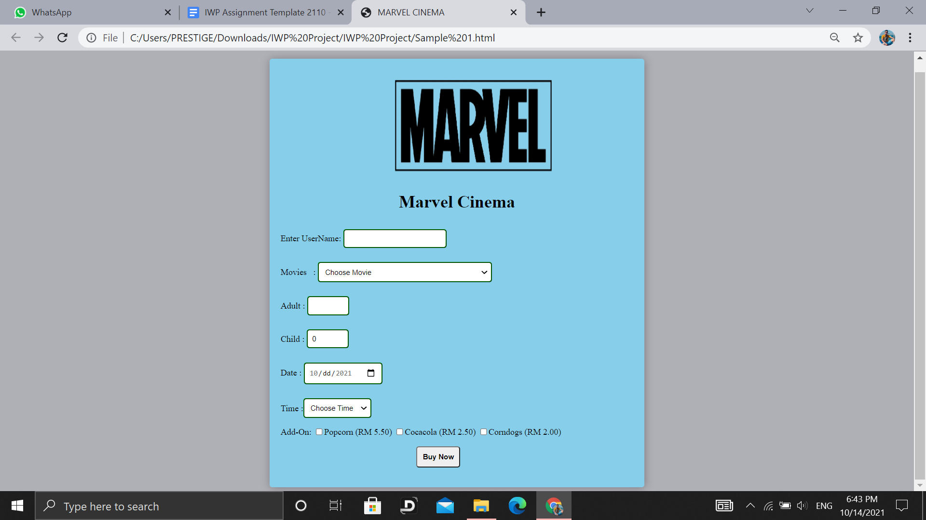

***Figure 2.1.1*** *Output 1*

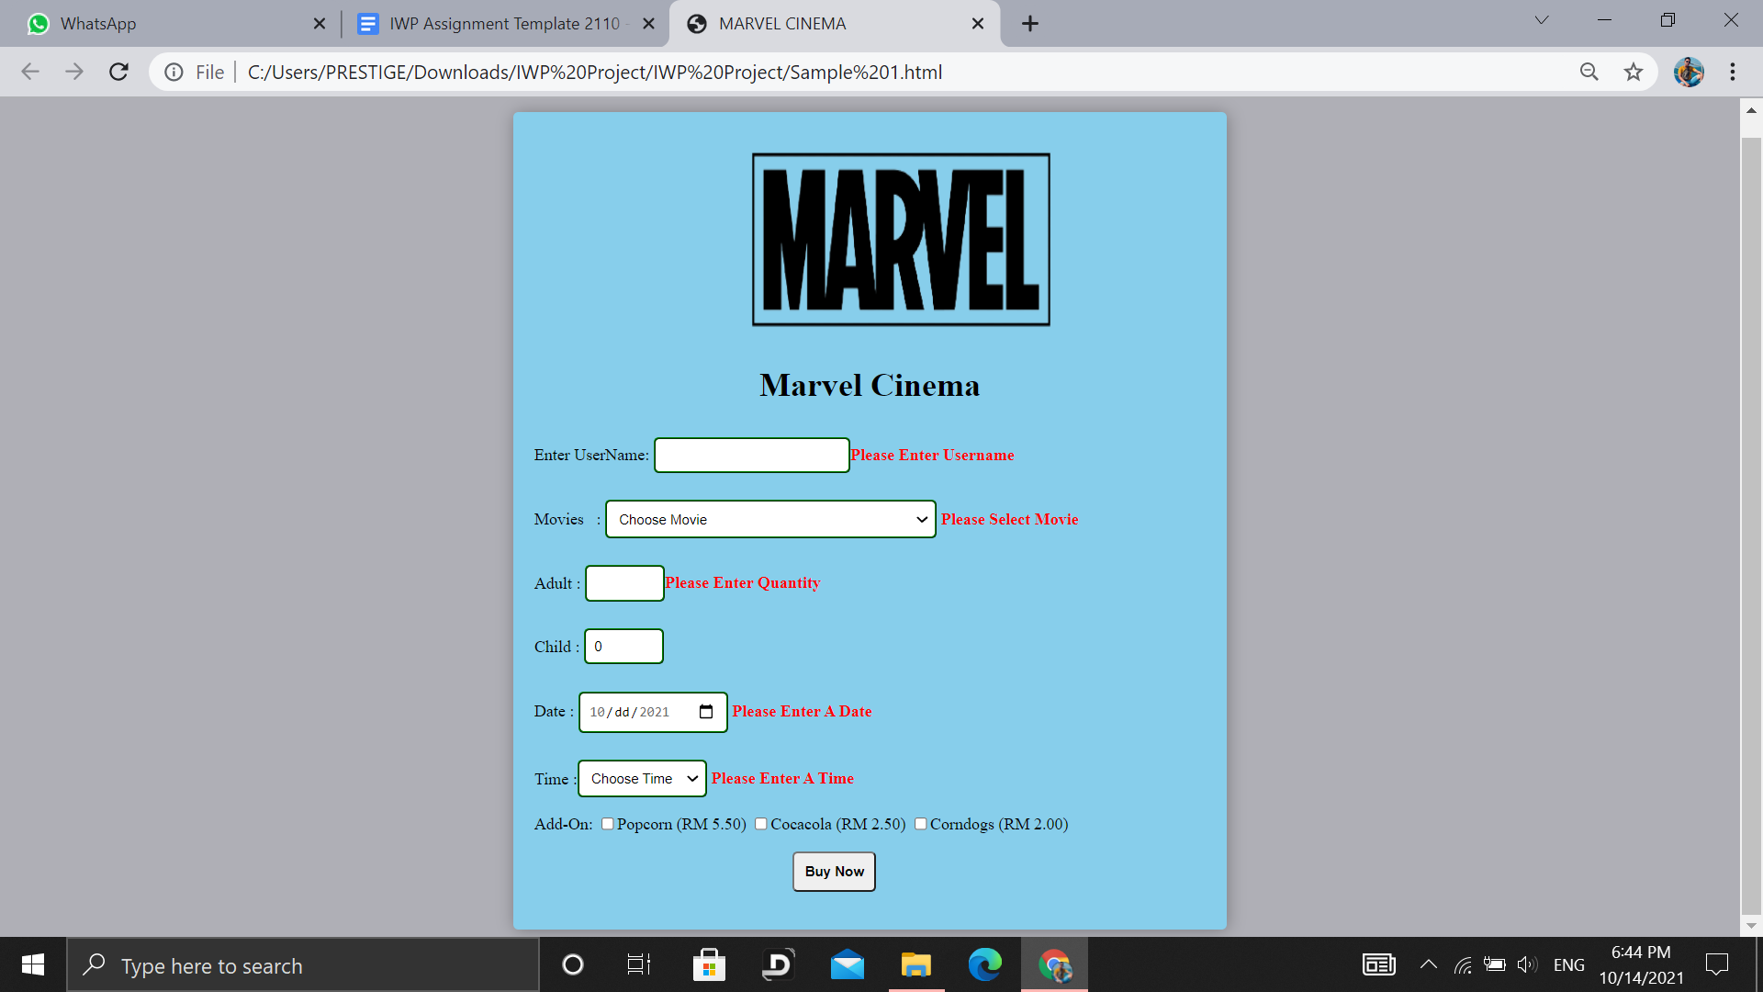

***Figure 2.1.2.*** *Output 1 Error*

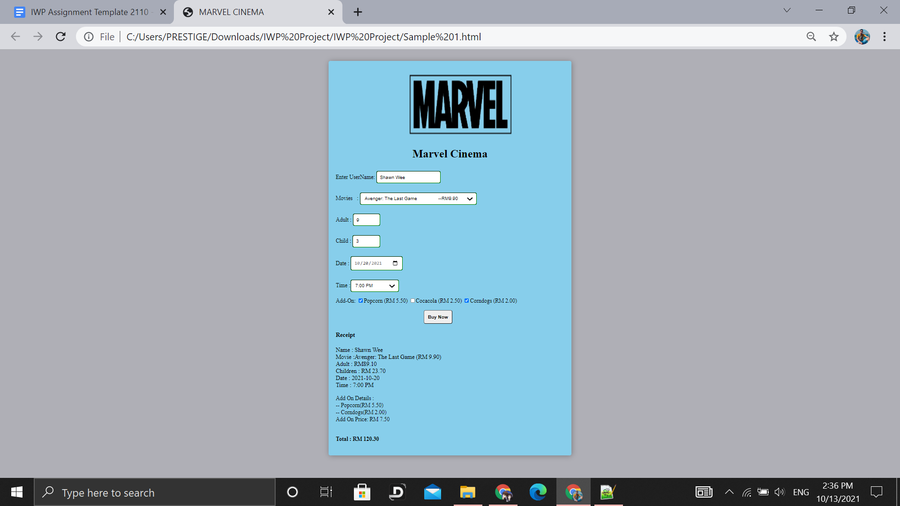

***Figure 2.1.3.*** *Output 1 Result 1*

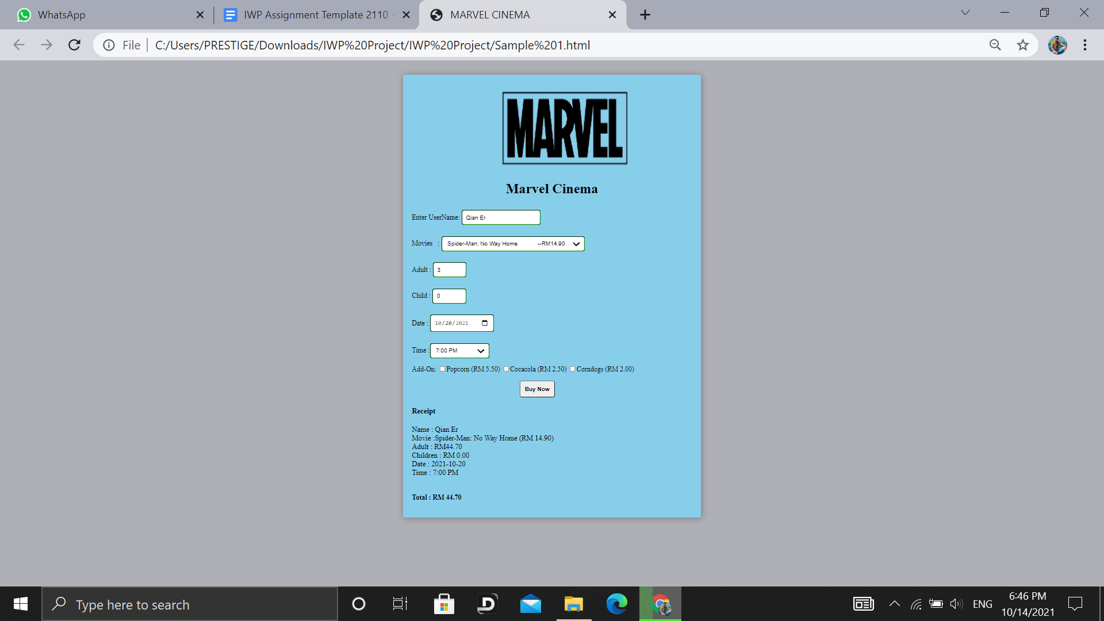

***Figure 2.1.4.*** *Output 1 Result 2*

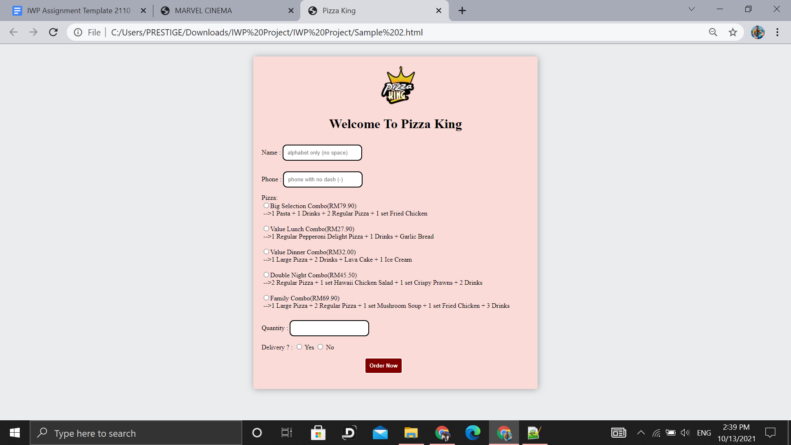

***Figure 2.2.1.*** *Output 2*

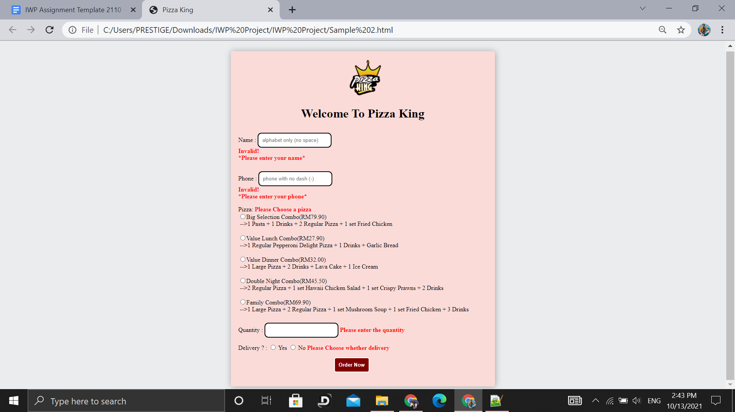

***Figure 2.2.2.*** *Output 2 Error*

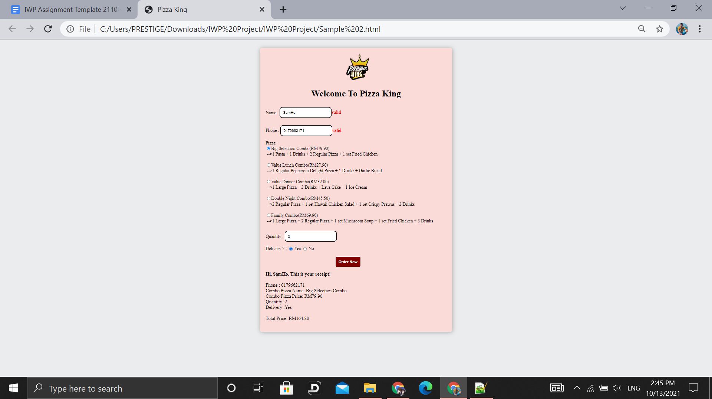

***Figure 2.2.3.*** *Output 2 Result*

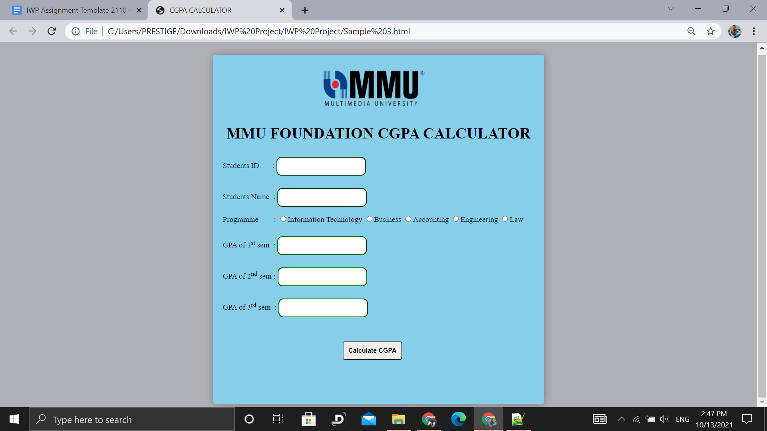

***Figure 2.3.1.*** *Output 3*

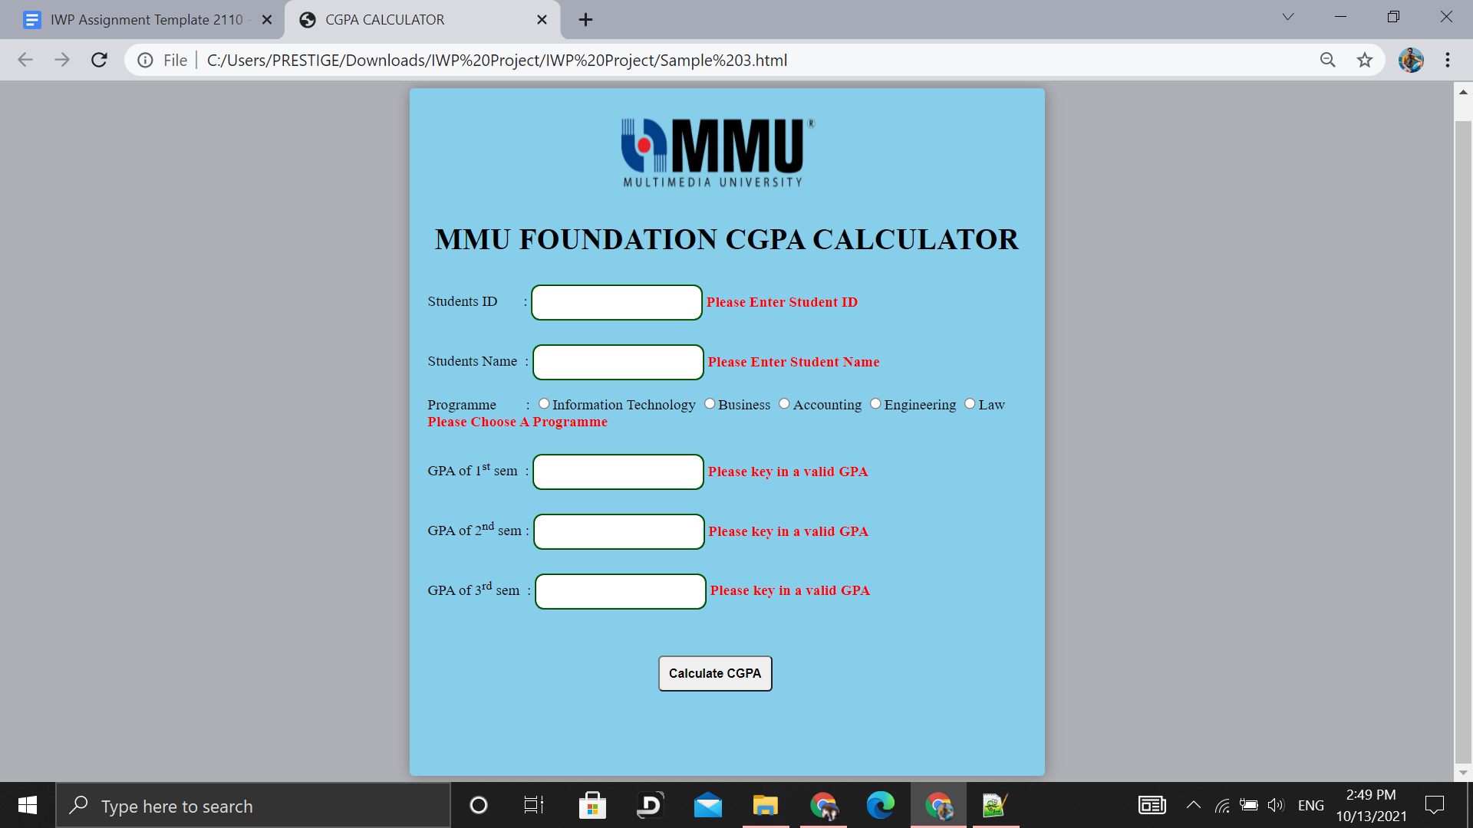

***Figure 2.3.2.*** *Output 3 Error*

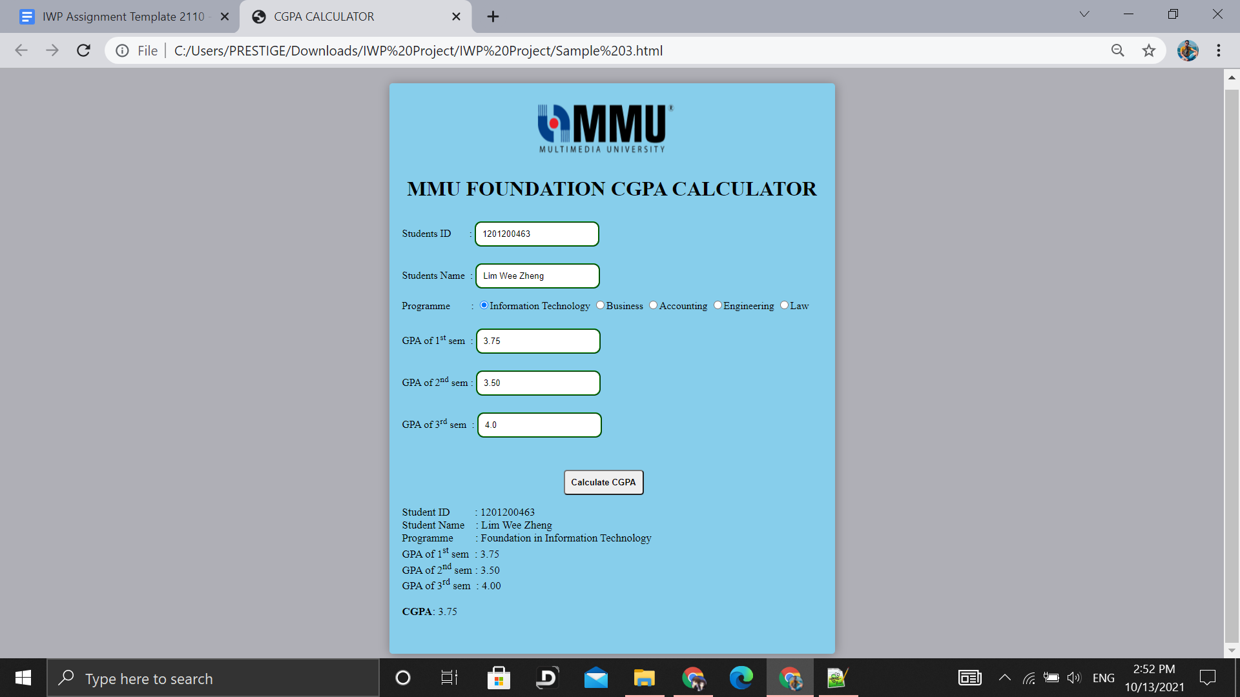

***Figure 2.3.3.*** *Output 3 Results*

**Video Link**

***https://www.youtube.com/watch?v=88xNvTIEOFw***